**Task-4 : Cloud Security Implementation**

**IMPLEMENT IAM POLICIES, SECURE STORAGE, AND DATA ENCRYPTION ON A CLOUD PLATFORM.**

**DELIVERABLE: CONFIGURED SECURITY POLICIES AND A REPORT DETAILING THE SETUP.**

First you must Create two instances

* Production Instances
* Development Instances

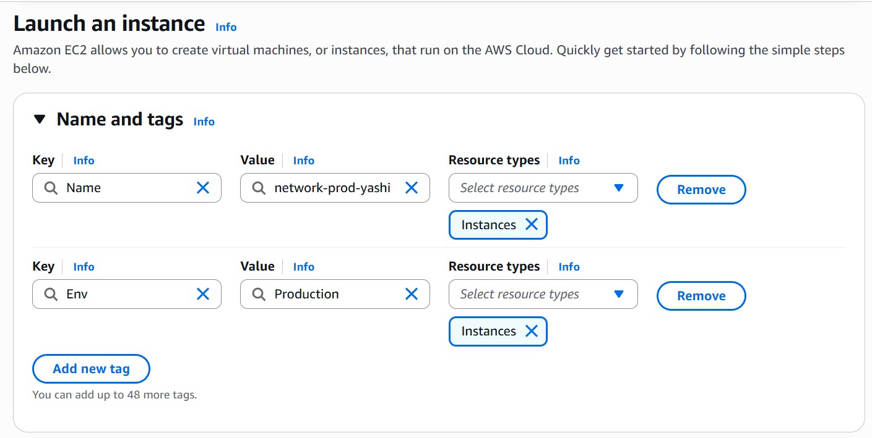

Here we need to add the Tag Production

Same, we need to add the Tag Development



Here we create the 2 instances

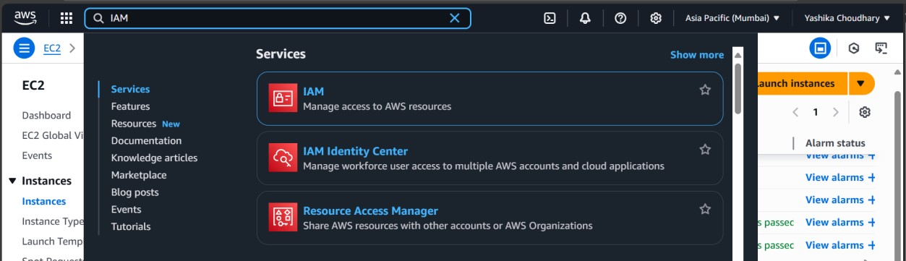

Now Go to IAM

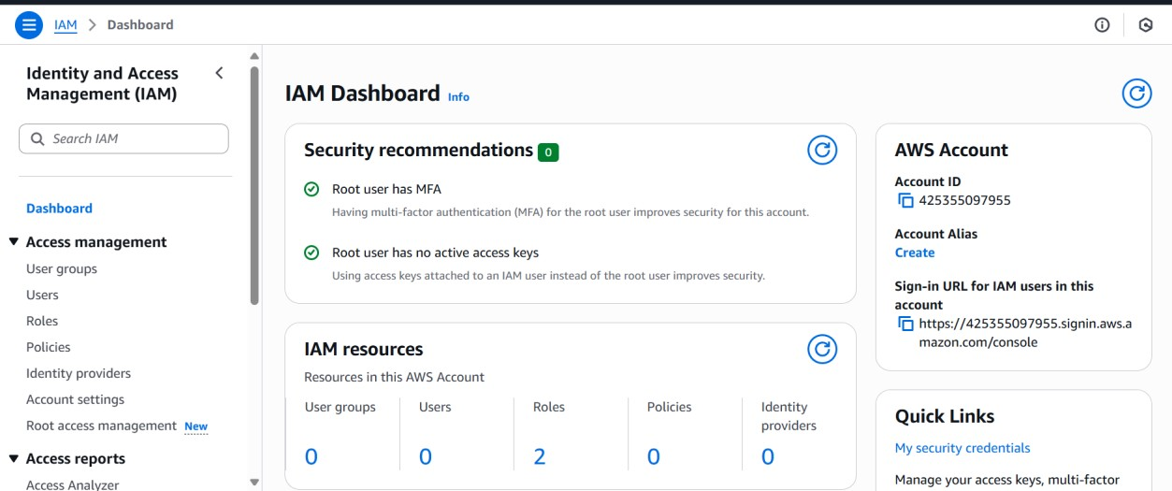

Click Policies form the left menu.

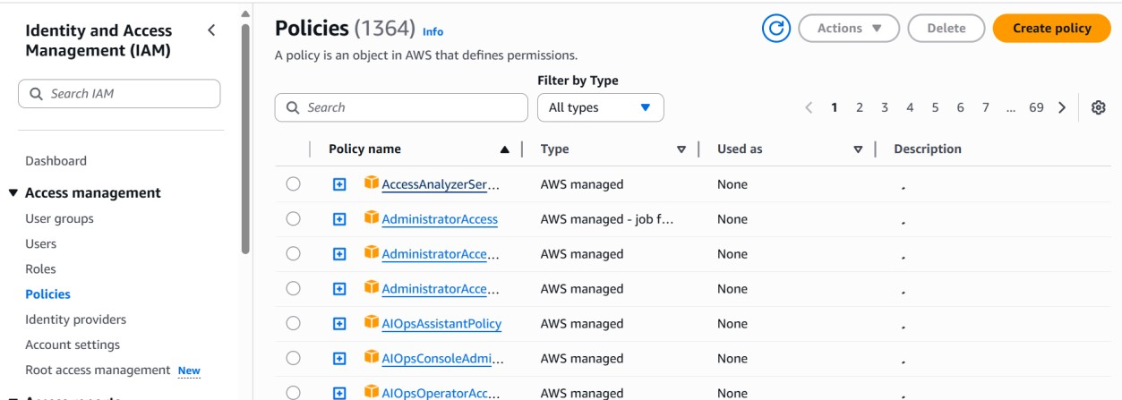

click on Create policy

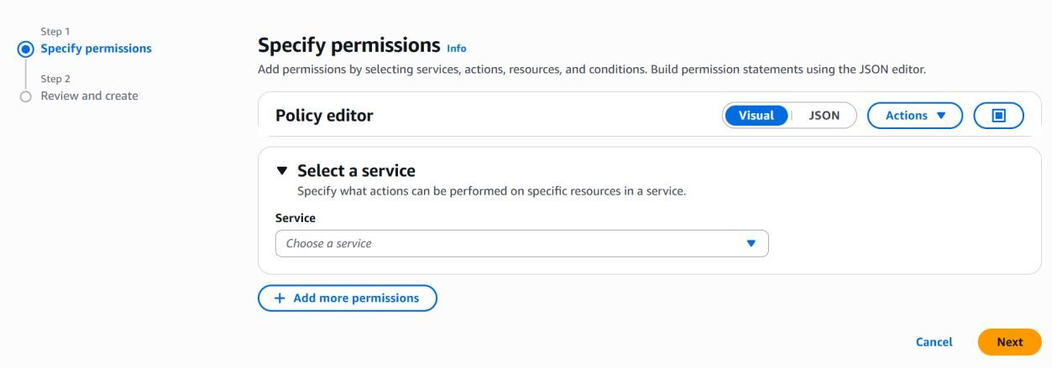

select the JSON mode

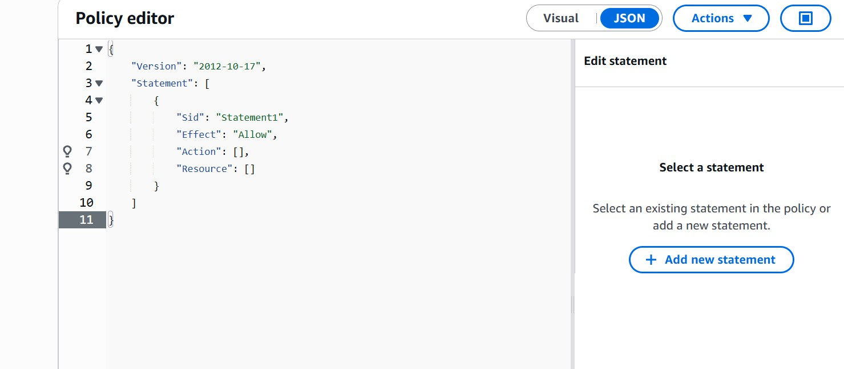

Copy the below json file.

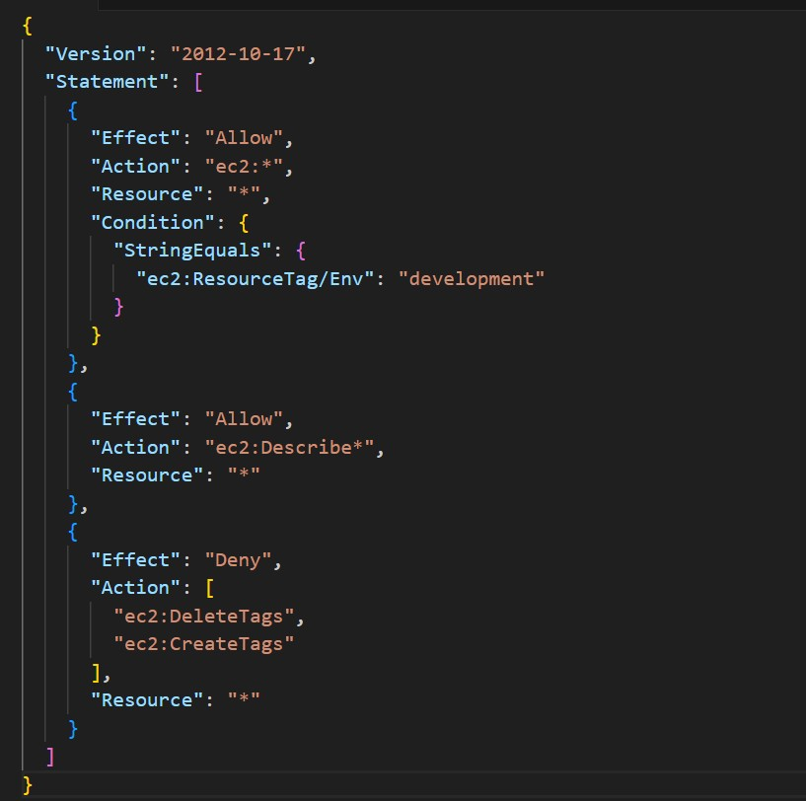

This json file will not allow an alias user to stop instances and delete tags

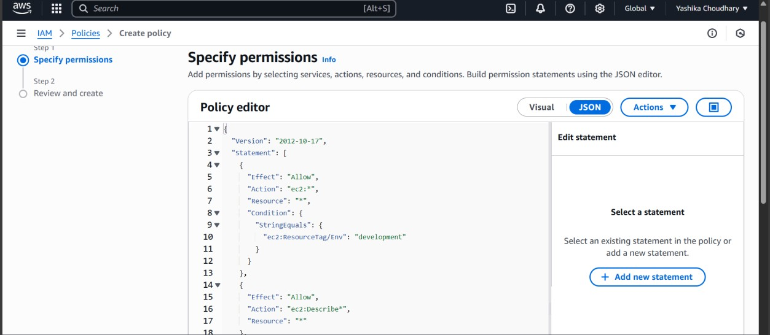

paste it here and click next

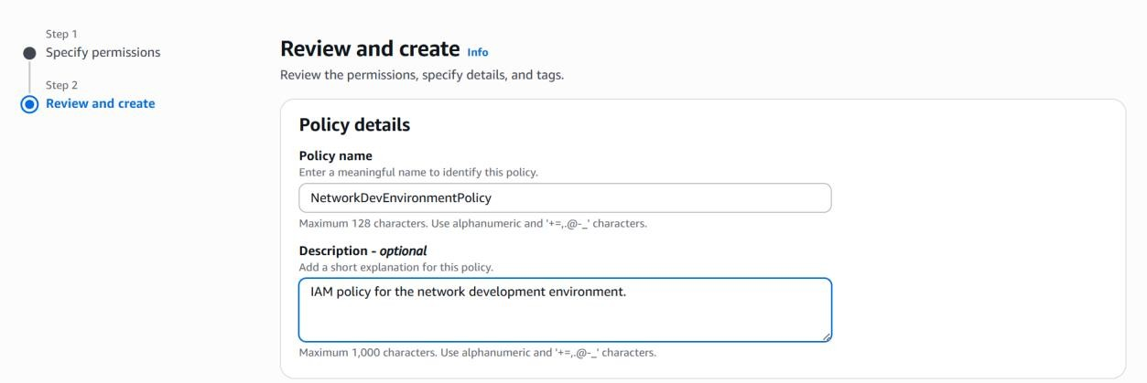

give a name and description

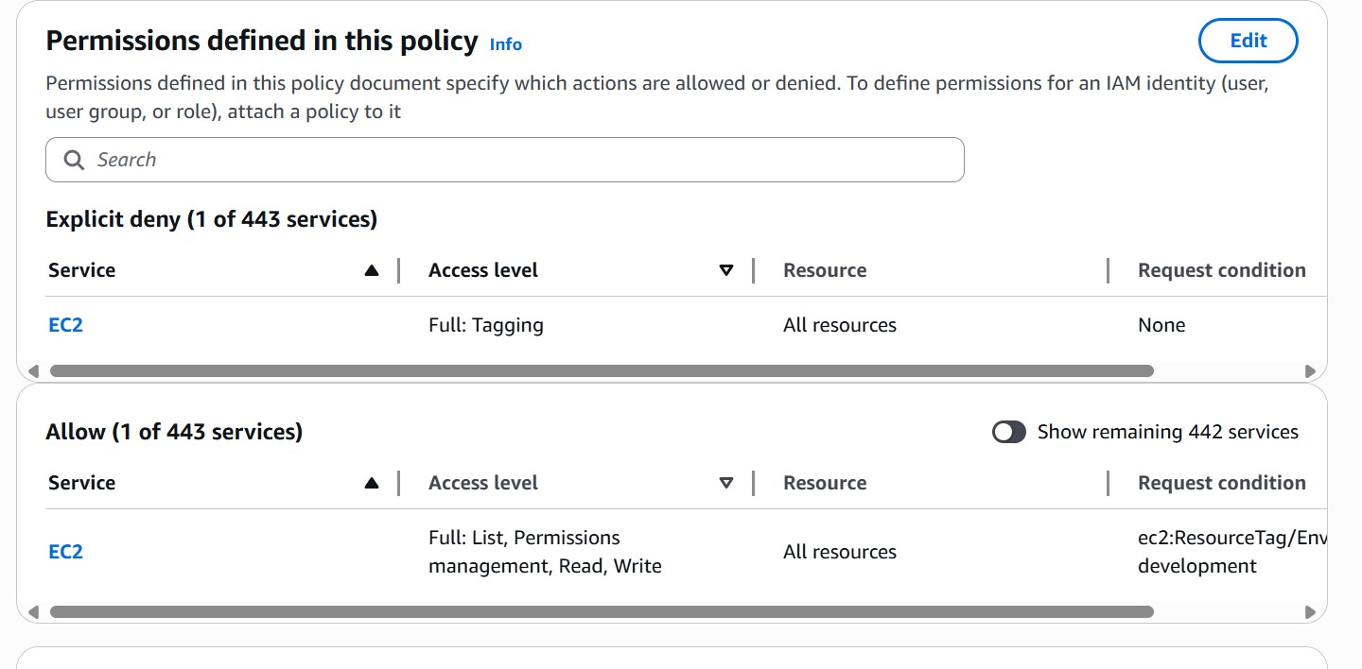

Keep this as default and click create

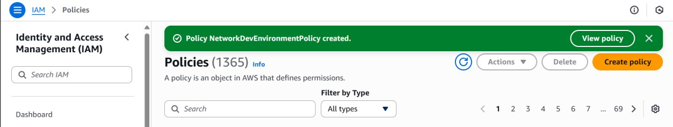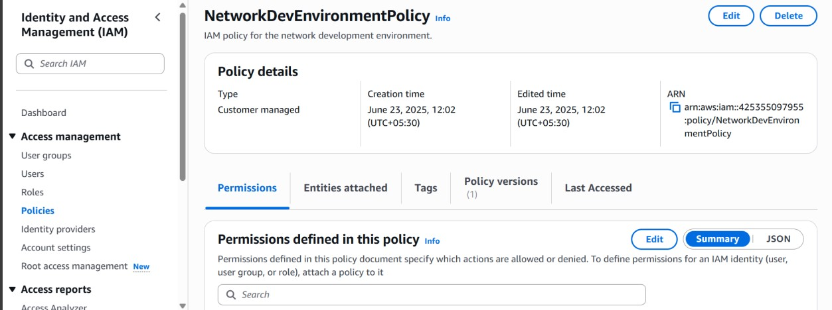

Here we created a Policy

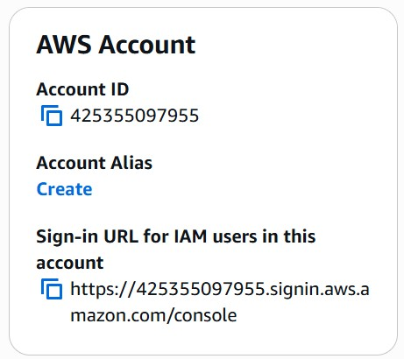

Now go to the dashboard → go to AWS Account → below Account Alias → click on Create

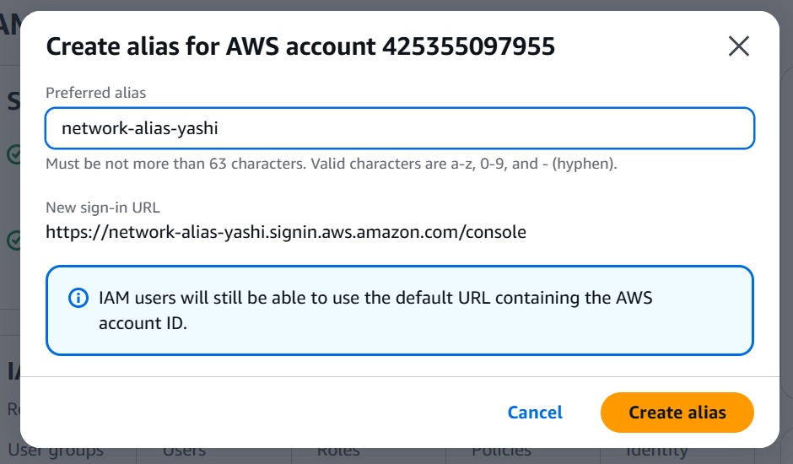

Give an name for it and click create

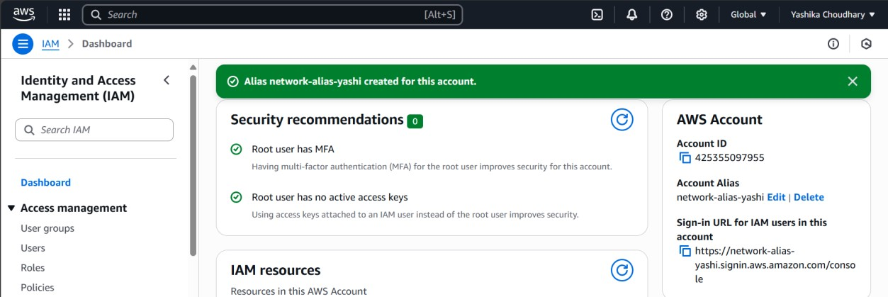

Here we created a alias user

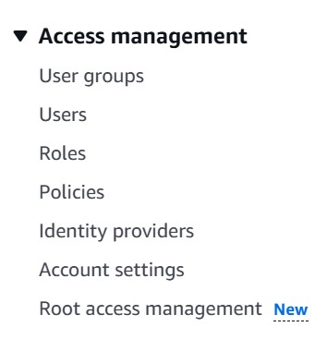

Now go to user groups from the left menu and click create group

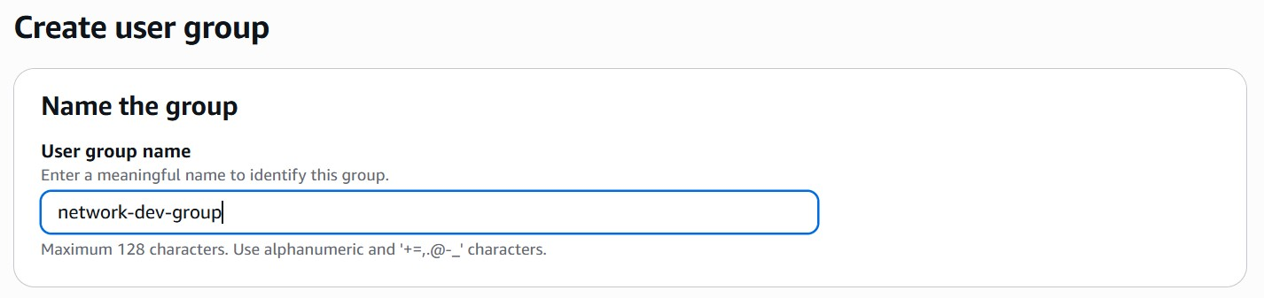

Give name

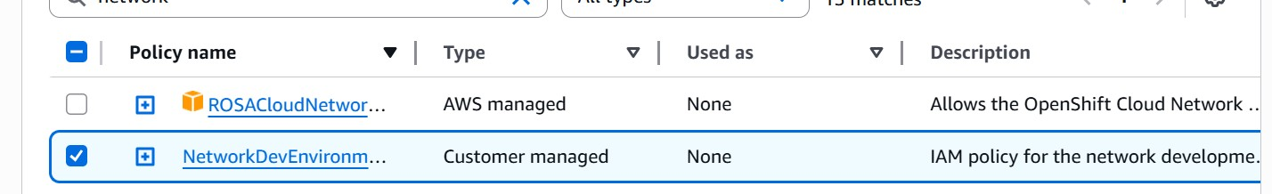

give the policy that we have created and press create

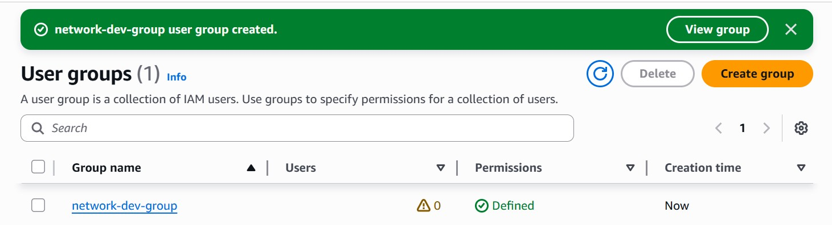

Here we created a user group

Go to the same side menu and click user → create user

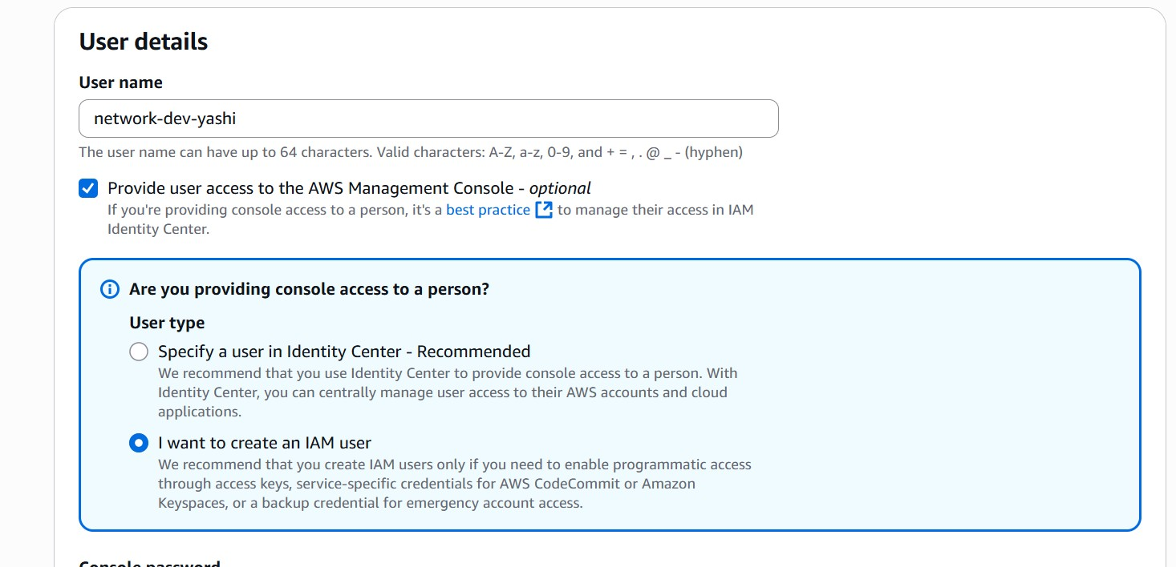

put in all the details show above

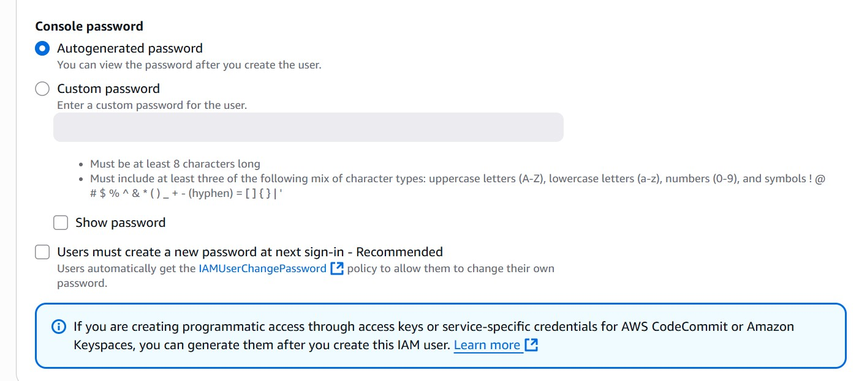

put in all the details show above

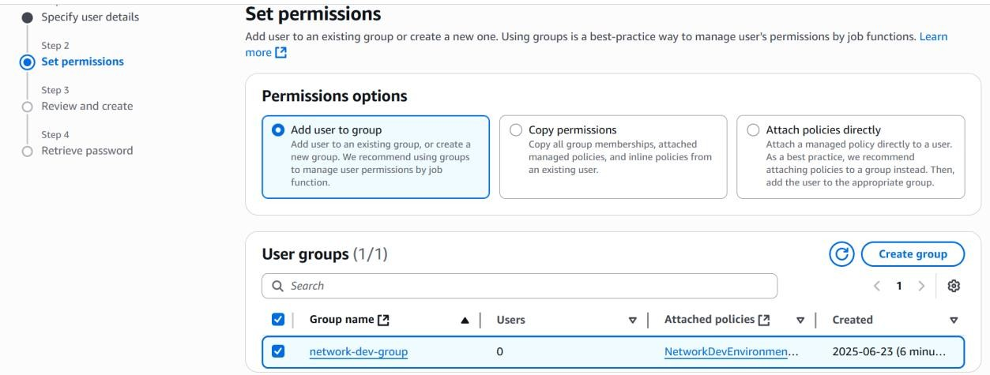

Give the user group we created

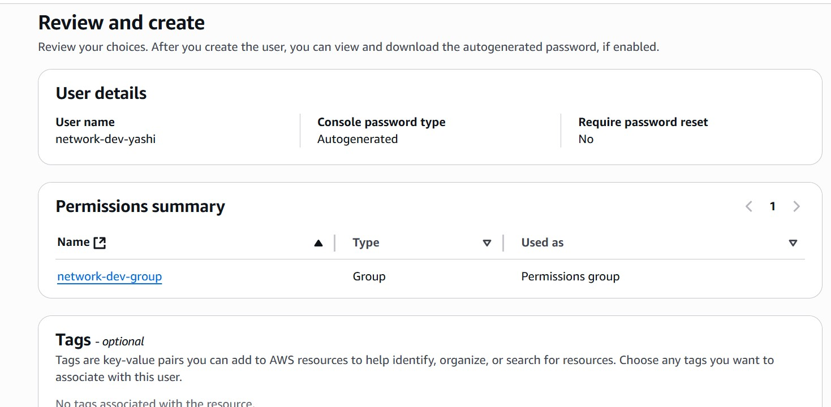

Press create user

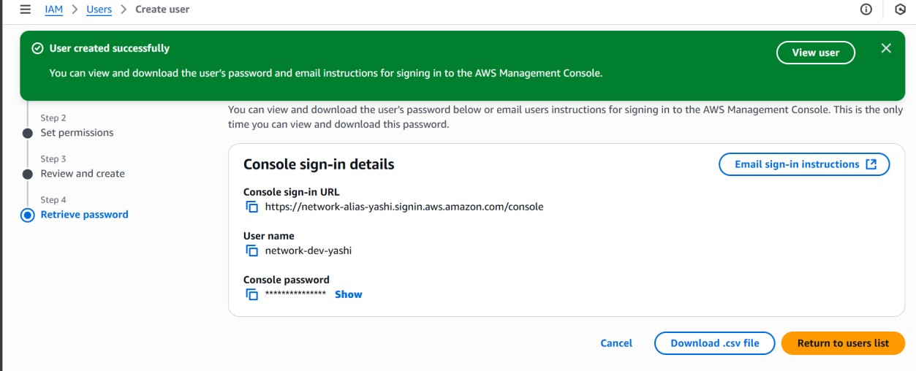

Here we created a user

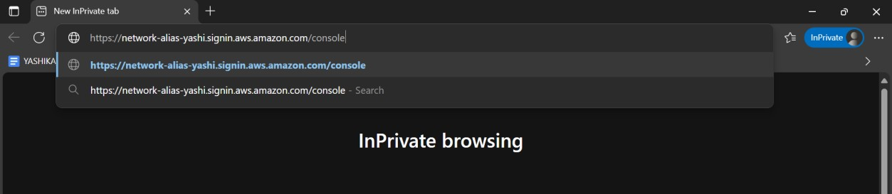

now go to Inprivate tab in your browser and paste the Console sign-In URL

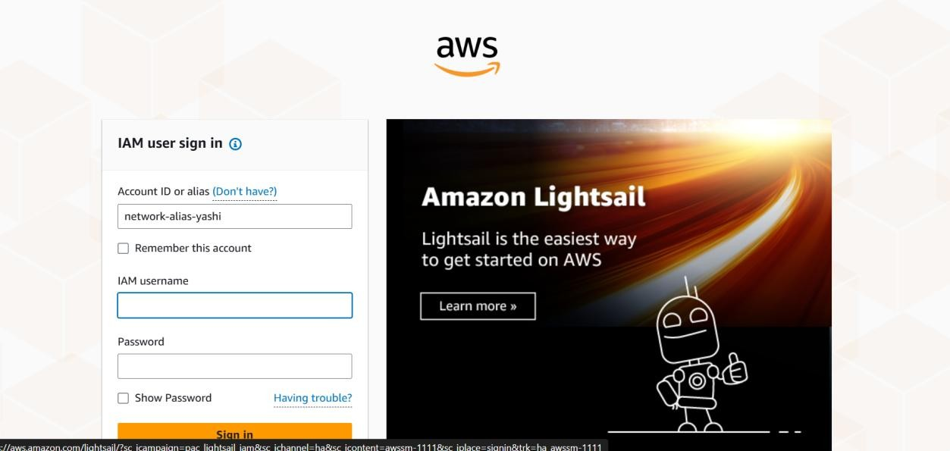

You can use the details given on the porta itself or download the csv file anyone can work

Fill out the login details

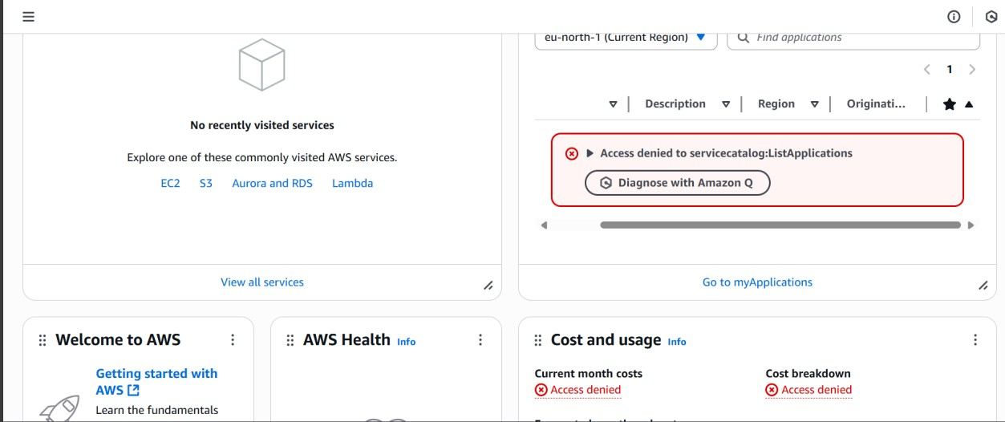

here you will see that there are limited access to you this access is based on the policy we created Now go to → EC2 → select production instance

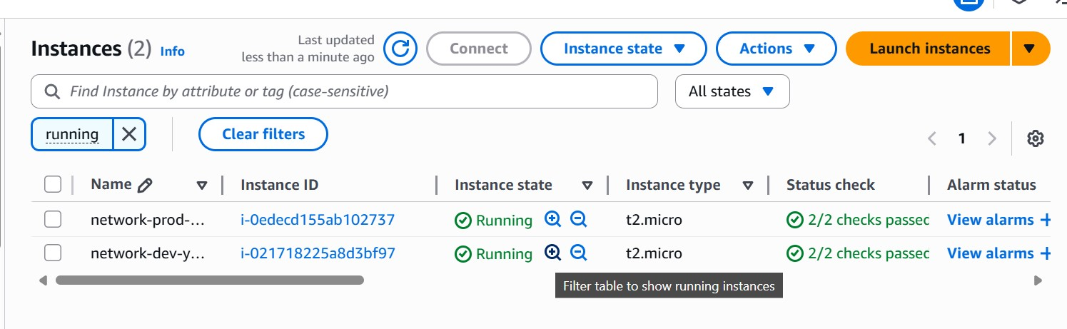

try stopping it

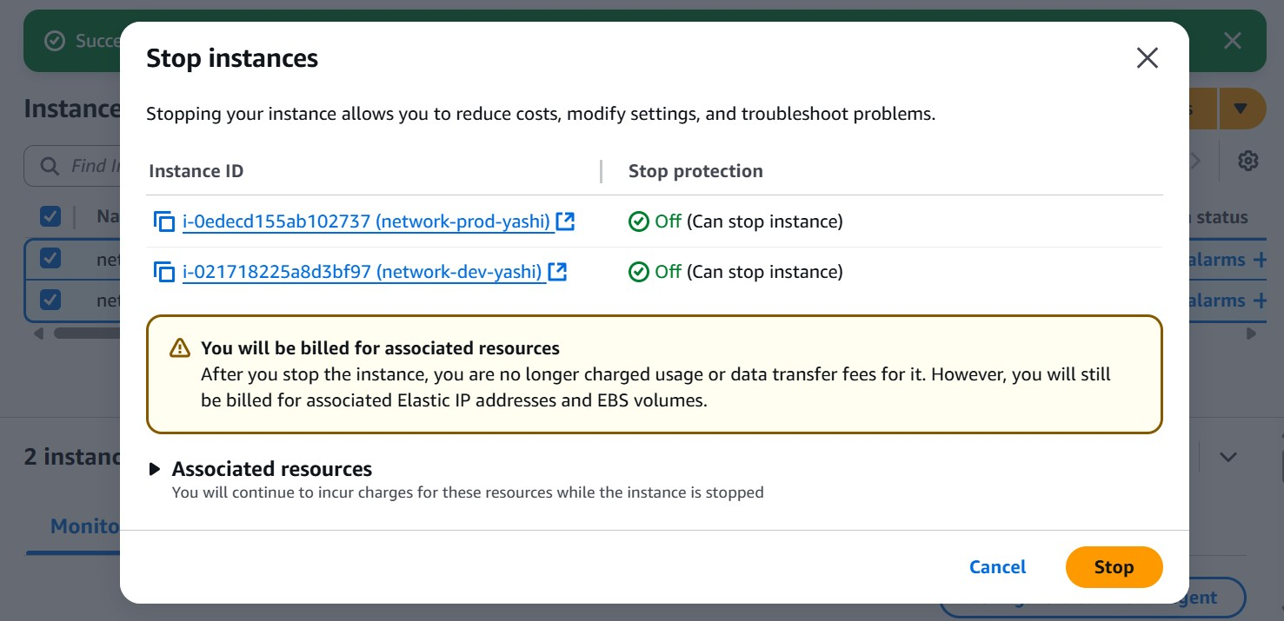

Here we can see that we can easily stop the instance because we have Permission. But only for limited sources.

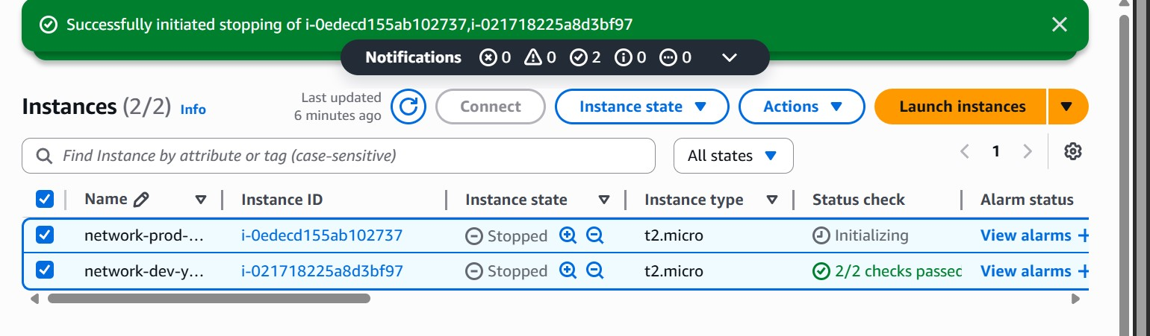

Finally stop the instances this is how we use IAM for access management